**Name: Varad Patil**

**PRN:120A2036**

**EXPERIMENT NO. 05**

**STUDY OF OPTICAL TIME DOMAIN REFLECTOMETER**

**EXPERIMENT NO. 05**

**STUDY OF OPTICAL TIME DOMAIN REFLECTOMETER**

**OBJECTIVE:**

The objective of this experiment is to determine fault in fiber optic link using

OTDR.

**EQUIPMENTS:**

1. Laser source-1550nm
2. Photodetector-PD3
3. Optical circulator
4. Fiber spools

**FORMULA USED:**

Length of an optical fiber is,

L= Vg.τ

Vg is the group velocity of light pulse in the medium

Τ is the pulse width.

Vg (λ) = C/ng (λ)

Sellemeier relation: ng (λ) = 1.451- 0.003(λ2 -1/λ2), λ in µm.

**THEORY:**

Whenever there is a break on optical fiber, then the light pulse suffers fresnel reflection & about 4% of incident light gets coupled back into the fiber & it propagates towards the I/P end of fiber.If we know speed of light pulse within the optical fiber,by measuring the time taken between the launch of pulse & detection of reflected pulse ,it is possible to estimate the distance of fiber break (See figure)

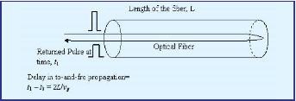

Principle of operation of OTDR

**PROCEDURE:**

1. Set up light runner.
2. Select the corresponding experiment from the experiment drop down menu & experimental window will appears on the screen.
3. Connect 1550 nm laser source to port 1 of optical circulator with the help of patch cord.
4. Connect port 2 of circulator with a patch cord.The other end of patch cord remains free (assume that fiber pathch cord is having a break at the end)
5. Connect the port 3 of circulator to PD3 by using a patch cord.
6. Connect the BNC connector adjacent to PD3 to CH2 of DSO using BNC cable.
7. Now set the pulse width as 2 µS &run the experiment by clicking on ‘start’ button.
8. After clicking on ‘start’ button, CH2 will display the pulse due to light reflected from the port 2 of the circulator (reflected light comes due to mismatch of the refractive index between fiber core &sorrounding medium

(air)).

1. Connect a BNC cable from OTDR CLK to CH 1of DSO for input reference clock.
2. Set the CH2 voltage fro, control panel given on right side in window(in case if amplitude of signal is very less)
3. Measure the time delay between the rising edges of reference clock pulse at CH1 & rising edge of reflected pulse.
4. Replace the patch cord at port 2 with a fiber spool of unknown length L.
5. Observe the shifting of reflected pulse in time domain at CH2, coming from the end of the fiber spool.
6. Measure the time delay between both the pulses.

**Calculation of spool length/ Location of fiber break:**

Knowing the speed of light in the fiber with core refractive index 1.46,the total length covered by the light pulse (twice the length of fiber)can be calculated. Speed of light in fiber with core refractive index of 1.46

Vg= 2.052*10^5Km/s.

L= (Vg* τ)/2

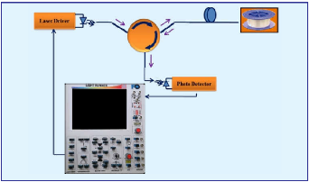

OTDR Setup

**OBSERVATION:**

|  |  |  |  |
| --- | --- | --- | --- |
| Pulse width in time  (µs) | Fiber Length  (km) | Time delay between the pulses, τ (µs) | Fiber Length =  Vg.τ/2 |
| 1550 | 3 | 29.55 | 3.02 |
| 1550 | 2 | 20.75 | 2.12 |
| 1550 | 1 | 11.32 | 1.16 |

**CONCLUSION:**

**The OTDR is mostly used to detect faults in an optic cable and length of an optic fiber cable. From the above experiment we see that we get the time delay from which we calculate the fiber length which was approximately close to its original length.**